ITP 359, SUMMER 2024

Homework 4
20 points
AUTOENCODER

Anomaly Detection in MNIST digits dataset
28 points (2 points each)
Please only submit the Python (from colab) notebook. No need for screenshots.
- Import the MNIST digits dataset.
- Rescale, reshape as necessary to prepare for an autoencoder with a flattened input (not convolutional).
- Partition the dataset.
- Build an autoencoder. Two Dense layers in the encoder. Two Dense layers in the decoder.
- Summarize the autoencoder.
- Compile it with mean squared error reconstruction loss.
- Train the autoencoder to reconstruct the input. Use at least 20 epochs.
- Predict the reconstructed images for all test images.
- Visualize any 20 test images along with their reconstructions.
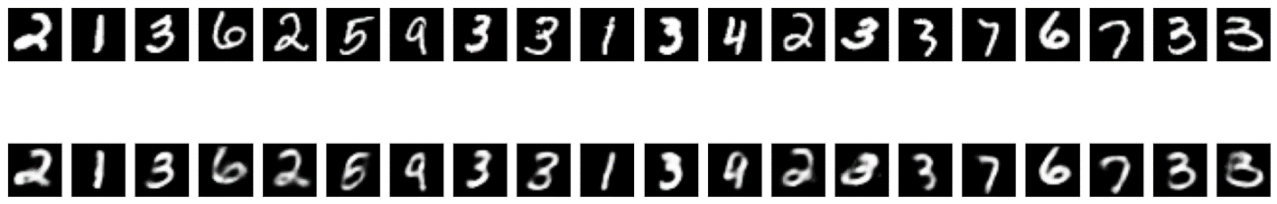
- Visualize a random image from the test dataset. Also visualize its reconstruction.
Reconstruction error is: 0.024504294618964195
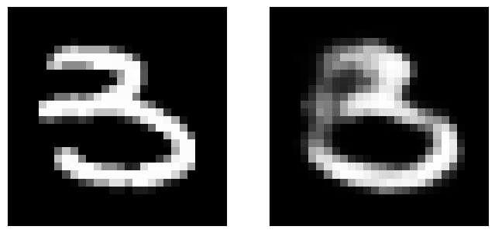

- Print the reconstruction error. (Hint.Use model.evaluate())
- Now rotate, flip upside down, or flip left to right the same random image and its reconstruction.
Flipped image reconstruction error: 0.05998418852686882
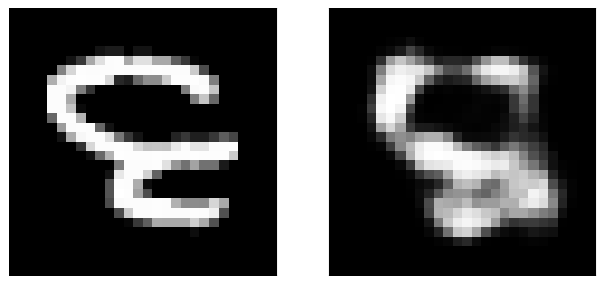

- Print the reconstruction error.
- Comment on the reconstruction error.
- Comment on anomaly detection of this image

